* **Wes所属公司、软件、试剂方法与仪器序列号：**

**公司名称：ProteinSimple**



**软件名称：Compass for SW**

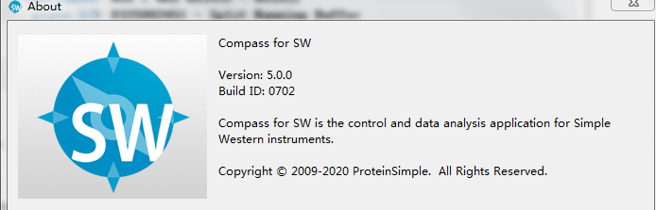

**实验模板和试剂盒规格、设备型号：**

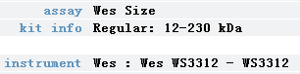

中分子或是大分子试剂盒

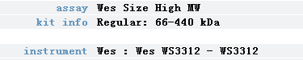

* **投稿回复编辑需要注意的点：**

1. **Wes检测灵敏度低至pg级（按质量来算），代表多少pg蛋白能被检测到。**
2. **曝光时间选HDR模式的话，是软件选择的最佳曝光时间，默认时间为1s。**
3. **特别注意：**

**很多评审专家可能还不了解Simple Western技术，误以为Wes条带太正太方像是P的。因此，在投稿的时候，建议适当引用技术原文和上传原始文档PDF。明确一点： Wes的Lane条带图是拟合出来的，看不大出差异变化，酌情附上真实定量的峰形图（实测数据）或有趋势变化的柱形图较为妥当。**

* **以上方法若还是不行，直接给审稿人发几篇文章说明不是用传统WB方法即可：**

1. In vivo gene editing in dystrophic mouse muscle and muscle stem cells 影响因子： 41.845PMID：[26721686](https://www.ncbi.nlm.nih.gov/pubmed/26721686" \t "https://www.geenmedical.com/_blank) 期刊年卷：Science 2016 Jan 22;351(6271)
2. Broad histone H3K4me3 domains in mouse oocytes modulate maternal-to-zygotic transition 期刊年卷：Nature 2016 09 22;537(7621)  影响因子： 42.778PMID：[27626377](https://www.ncbi.nlm.nih.gov/pubmed/27626377" \t "https://www.geenmedical.com/_blank)
3. Somatic inflammatory gene mutations in human ulcerative colitis epithelium 影响因子： 42.778 PMID：[31853059](https://www.ncbi.nlm.nih.gov/pubmed/31853059" \t "https://www.geenmedical.com/_blank)
4. Nitrosative stress drives heart failure with preserved ejection fraction 影响因子： 42.778 PMID：[30971818](https://www.ncbi.nlm.nih.gov/pubmed/30971818" \t "https://www.geenmedical.com/_blank)
5. Melatonin alleviates cognition impairment by antagonizing brain insulin resistance in aged rats fed a high‐fat diet 影响因子： 14.528PMID：[31050371](https://www.ncbi.nlm.nih.gov/pubmed/31050371" \t "https://www.geenmedical.com/_blank)期刊年卷：J Pineal Res 2019 Sep;67(2)

* **方法学书写可参考已发表文献相关格式：**

1. **Western blot**

RPE were scraped from fibrin in TPI buffer with 1% Triton-X, 20mM Tris, 150 mM NaCL, 5 mM EDTA, pH 8.0. Cells were lysed for 1h at 4 C. Samples were diluted and resolved on a capillary electrophoresis-based western blot instrument (Protein Simple Wes; San Jose, CA) using manufacturer’s solution kits and protocol.Primary antibodies included RPE65 (401.8B11.3D9), Bestrophin 1(pAB125), CRALBP (B2), and b-actin (AC-15).

1. **Simple Wes size assays (capillary-based electrophoresis).** The methods were

adopted according to the protocol provided by the manufacturer (Protein Simple/

Biotechne, cat No: SM-W004). Briefly, cells were lysed in Buffer A (see the recipe

above in IP method in supplementary information) with complete protease inhibitors

(Thermo Scientific). The cell lysates were cleared by 13,000 × g centrifugation.

The lysates were diluted with an equal volume of distilled water. Protein

concentrations were measured with a Nanodrop spectrophotometer (Thermo

Scientific). The cell lysates were further diluted with 0.1× Sample buffer to achieve a

protein concentration of 0.4 μg/μl. In total, 1.4 μl of 5× Master mix was added to

5.6 μl of diluted cell lysates. Five microlitres of the mixtures were loaded to the

Wes setup (Protein Simple/Biotechne, CA) for the Simple Wes assays. In total,

12–230 kDa separation capillaries were used in this work. Of note, all buffers were

DTT-free, as the samples were run in native conditions. The antibody dilutions

were applied, as indicated in each figure legend.

1. **Capillary-based Immunoassay**

For APC expression analysis, organoids were grown under optimal growth culture conditions. For phospho-ERK-production analysis,organoids were grown under optimal growth culture conditions, followed by cultured without EF for 3 days and with or without 1 m Mpan ERBB receptor inhibitor (Merck Millipore). For RHOA expression analysis, organoids were grown under optimal growth culture conditions, followed by cultured with doxycycline (50 ng/ml) for 6 hr. Proteins were extracted from organoids using Cell Lysis Buffer (#9803, CST) according to the manufacturer’s instructions. Protein separation and detection were performed using an automated capillary electrophoresis system (Simple Western system and Compass software; protein simple). Wes Separation Capillary Cartridges for 66-440 kDa and 12-230 kDa were used for APC and the other proteins, respectively. Antibodies against the following proteins were used; ERK-1/2 (#9102, CST, 1:50), phospho ERK1/2 (T202/Y204) (#4370, CST, 1:50), APC (#2504,CST, 1:50), RHOA (#2117S, CST, 1:50) and anti-b actin (#A1978, Sigma, 1:50). Signals were detected with an HRP-conjugated secondary anti-rabbit antibody and were visualized using protein simple software.

1. Protein concentration was measured using Coomassie (Bradford) protein assay.

Cell and tissue lysates from normal human and SMA patient dividing cells, normal (non-SMA) and SMA mouse tissues and normal (non-SMA) human and SMA patient

spinal cord tissues were prepared and diluted to protein concentration of 0.2 mg/ml using sample preparation kit (Protein Simple) for automated capillary western blot system, Wes System (Protein Simple), which utilizes capillary based electrophoretic separation and detection of proteins. Mouse spinal cord, tissues were isolated from 7-day-old non-SMA and SMA mice. Cell or tissue extracts with equal protein concentration were mixed with 0.1× sample buffer and 5×fluorescentmaster mix. The protein samples and the biotinylated ladder were denatured by heating at 95◦C for 5

min. Protein samples, biotinylated ladder, primary antibodies (diluted 1:100 with antibody diluent), horseradish peroxidase (HRP)-conjugated secondary antibodies, chemiluminescence substrate and wash buffer were dispensed into respective wells of the assay plate and placed in Wes equipment. Signal intensity (area) of the protein was normalized to the peak area of loading control -actin or -tubulin. Quantitative analysis was performed using Compass software (Protein Simple) and statistical analysis of data was performed as described in below in ‘Statistical Analysis’ section.

1. **Western Analysis.** Western analysis on blots for GARP1 were performed as previously described using a custom designed affinity purified antibody (Genscript) with the epitope CVSRITPLPATSGTQYHG. Westerns were completed in the Wes automated Protein Simple system in order to determine expression levels of CNGB1 proteins. Retinas were dissected into homogenization buffer (10 mM Tris, pH 7.5, 0.5% Triton-X 100) and 1X Sigma Protease inhibitor cocktail (Roche, Florence, South Carolina) for all genotypes. A protein assay (BioRad) was performed to determine protein concentration and 0.15 mg/ml was used. CNGB1 protein expression was determined using an automated “Wes” Western blotting system (ProteinSimple, Inc., San Jose, CA, USA), The Wes is a capillary electrophoresis based immunodetection system that provides higher reproducibility at lower sample concentration, increased sensitivity, and higher resolution than traditional western blot protocols. The Wes ProteinSimple system was used according to the manufacturer’s instructions, default settings were used. The N-terminal antibody (N-*Cngb1;* QEPPEPKDPPKPPGC) was used (1:500) to detect expression of the β -subunit and GARP2. N-*Cngb1* was generated in rabbit and affinity purified (Genscript Inc; Piscataway, NJ). Data analysis was performed using the Compass Software (ProteinSimple) and quantitation was determined by normalizing the area under the curve of the β -subunit and GARP2 peaks by the area under the curve of the ProteinSimple internal standard peak. Representative computer generated electerophoretic images were generated by the Compass Software. Images shown contain information from capillaries run over multiple trials. The computer generated electrophoretic images displayed larger product size than is normally observed for these proteins. The very low pI of the proteins is likely the basis for the altered migration, which is even more pronounced in the capillary than is observed in an acrylamide gel51. Previous reports comparing capillary based protein migration to standard SDS gels have also shown differences (either higher or lower) in size of proteins between the two techniques.
2. **HCV-Wes procedure.** A commercially available 4th-generation recombinant HCV antigen (46 kDa) (ProSpec Bio, Israel) containing a medium-sized core (55 amino acids), nonstructural protein 3 (NS3) (226 amino acids), three epitopes from the NS4 protein, and three epitopes from the NS5 protein was used to detect IgG antibodies to HCV. Prior to loading the samples on the WES separation module cartridge (ProteinSimple, San Jose, CA), antigen was diluted 1:500 in 0.1_ sample dilution buffer (ProteinSimple, San Jose, CA), and the secondary antibody and plasma samples were diluted 1:2,000 and 1:20 in the antibody diluent (ProteinSimple, San Jose, CA). The cartridges were loaded according to the manufacturer’s instructions, with the following modifications: diluted antigen was run in the capillaries as the“sample,” diluted human serum was run as the “primary antibody,” and the 1:2,000 dilution of the goat anti-human IgG labeled with horseradish peroxidase (HRP) (SeraCare, Milford, MA) replaced the secondary antibody from the anti-rabbit detection module (ProteinSimple, San Jose, CA). All reagents were loaded into a sample cartridge placed into the automated immunoblotter, Wes, with the capillary cartridge. The 4th-generation antigen was separated in the proprietary separation matrix in the capillaries by size. The anti-HCV antibodies from the serum or plasma samples are captured/bound to the cross-linked HCV antigen, and a signal is produced from the HRP-labeled secondary antibody, which is digitally recorded upon a chemiluminescent reaction. The anti-HCV antibodies from the diluted serum or plasma samples are run over the cross-linked HCV antigen, and the capillary is washed. HRP-labeled secondary antibody is then applied over the bound antibodies and washed again. The signal, produced upon the primary antibody from human serum or plasma binding to the anti-HCV antigen, is measured and digitally recorded after a 5-s exposure. Compass software, supplied by ProteinSimple, captures data as a chemiluminescent image of the capillary. The software determines when the signal is higher than the noise and records it in the form of peaks or bands (both views are available). The background determination is based on a “dark” image of the loaded capillaries (i.e., immobilized proteins and antibodies) taken just prior to substrate loading (e.g., luminol/peroxide). This will capture any artifacts derived from sources not induced by the enzymatic reaction. Next, the substrate is loaded, and a subsequent image is captured with emission from the luminol. Compass will then subtract the emission image with the dark image pixel for pixel to determine corrected signal responses. A system control,provided in the running buffer, is used with every sample to monitor uniformity of separation between different capillaries. In the case of HCV-WES, if a band of 42 kDa is detected by the instrument, the sample is considered anti-HCV positive regardless of the band intensity value.
3. 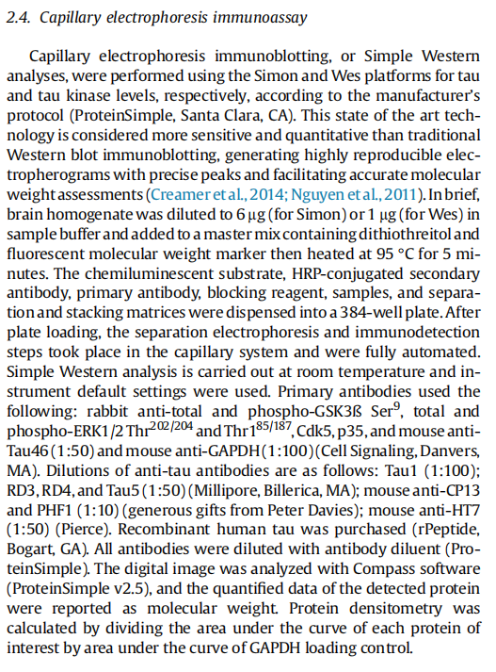
4. 